**Day 3**

**C++ Recursion, Arrays, Strings, Structures**

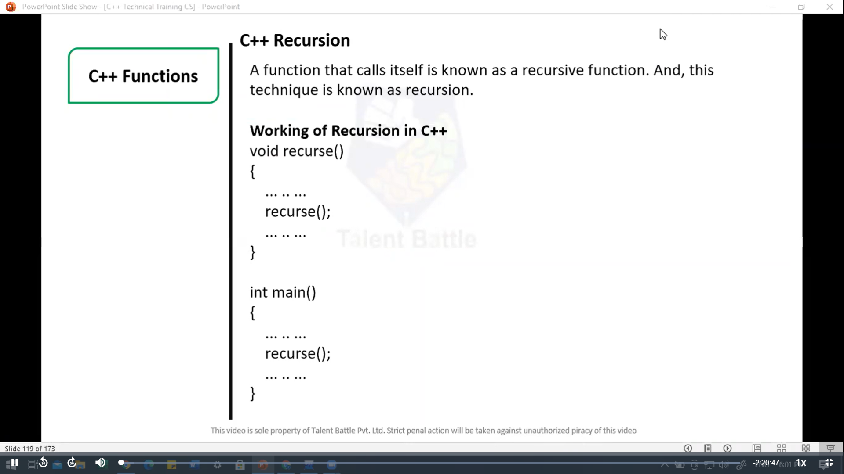

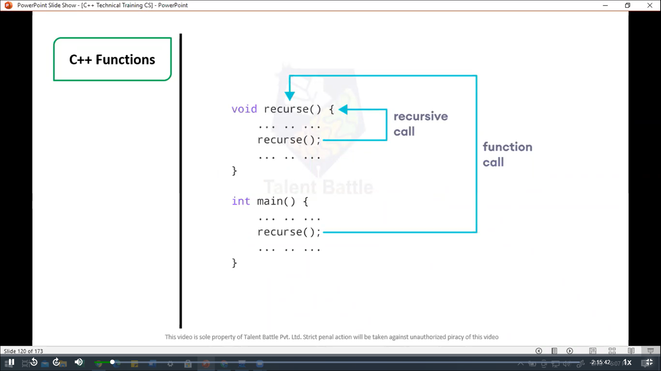

// C++ Recursion, Arrays, Strings, Structures

// Factorial of n = 1*2*3*...*n

#include <iostream>

using namespace ***std***;

int *factorial*(int); // functoin prototype

int *main*(){

  int n***,*** result;

  cout ***<<*** "Enter a non-negative number: ";

  cin ***>>*** n;

  result = *factorial*(n);

  cout ***<<*** "Factorial of " ***<<*** n ***<<*** " = " ***<<*** result;

  return 0;

}

int *factorial*(int ***n***) {

  if(n > 1){

    cout ***<<*** n ***<<*** " " ***<<*** n\**factorial*(n-1) ***<<*** endl;

    return n * *factorial*(n-1);

  } else {

    return 1;

  }

}

**==========================================**

**Output:**

**Enter a non-negative number: 5**

**Factorial of 5 = 120**

**--------------------------------**

**Process exited after 2.145 seconds with return value 0**

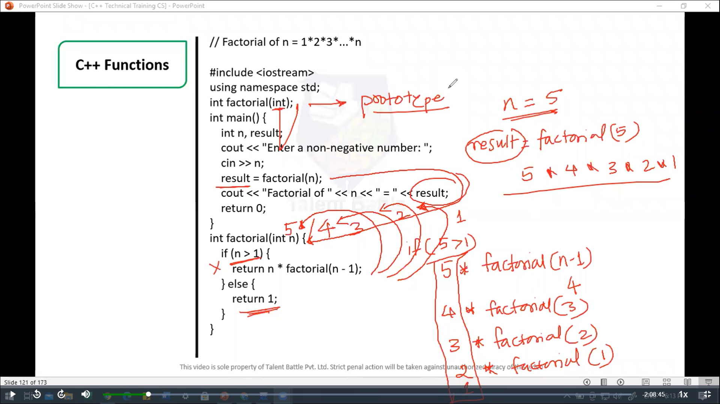

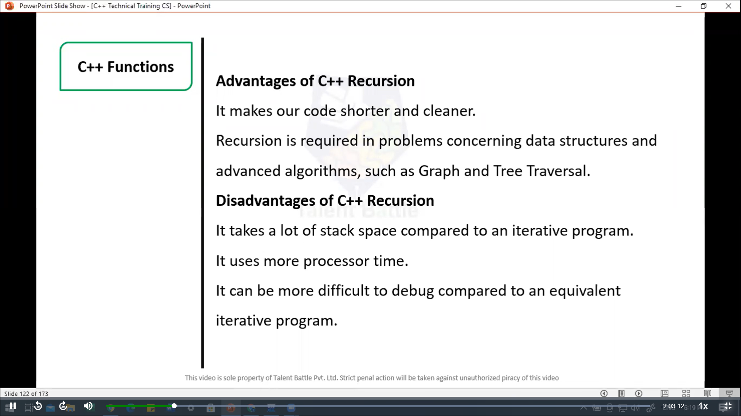

//======================================================

// C++ Return by Reference

/*

In C++ Programming, not only can you pass values by reference

to a function but you can also return a value by reference.

*/

#include <iostream>

using namespace ***std***;

// Global variable

int num;

// function declaration

int& *test*();

int *main*(){

*test*() = 5;

  cout *<<* num;

  return 0;

}

int& *test*(){

  return num;

}

**=============================================================**

**5**

**--------------------------------**

**Process exited after 0.1432 seconds with return value 0**

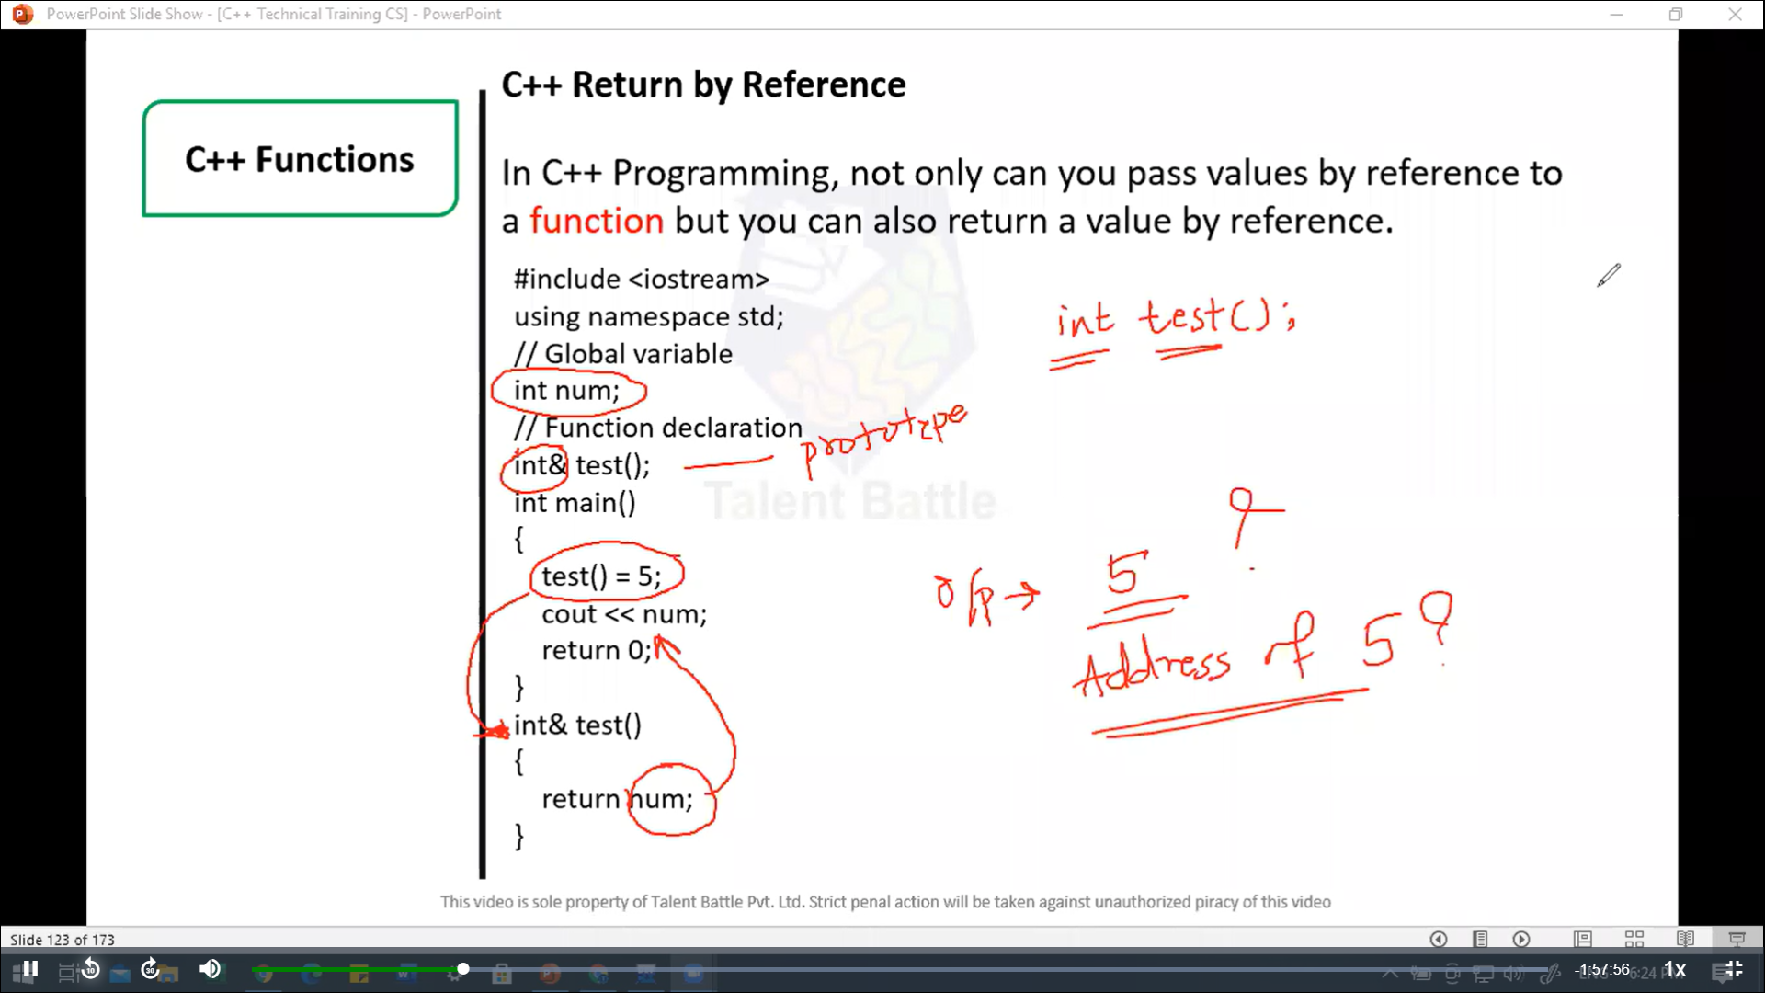

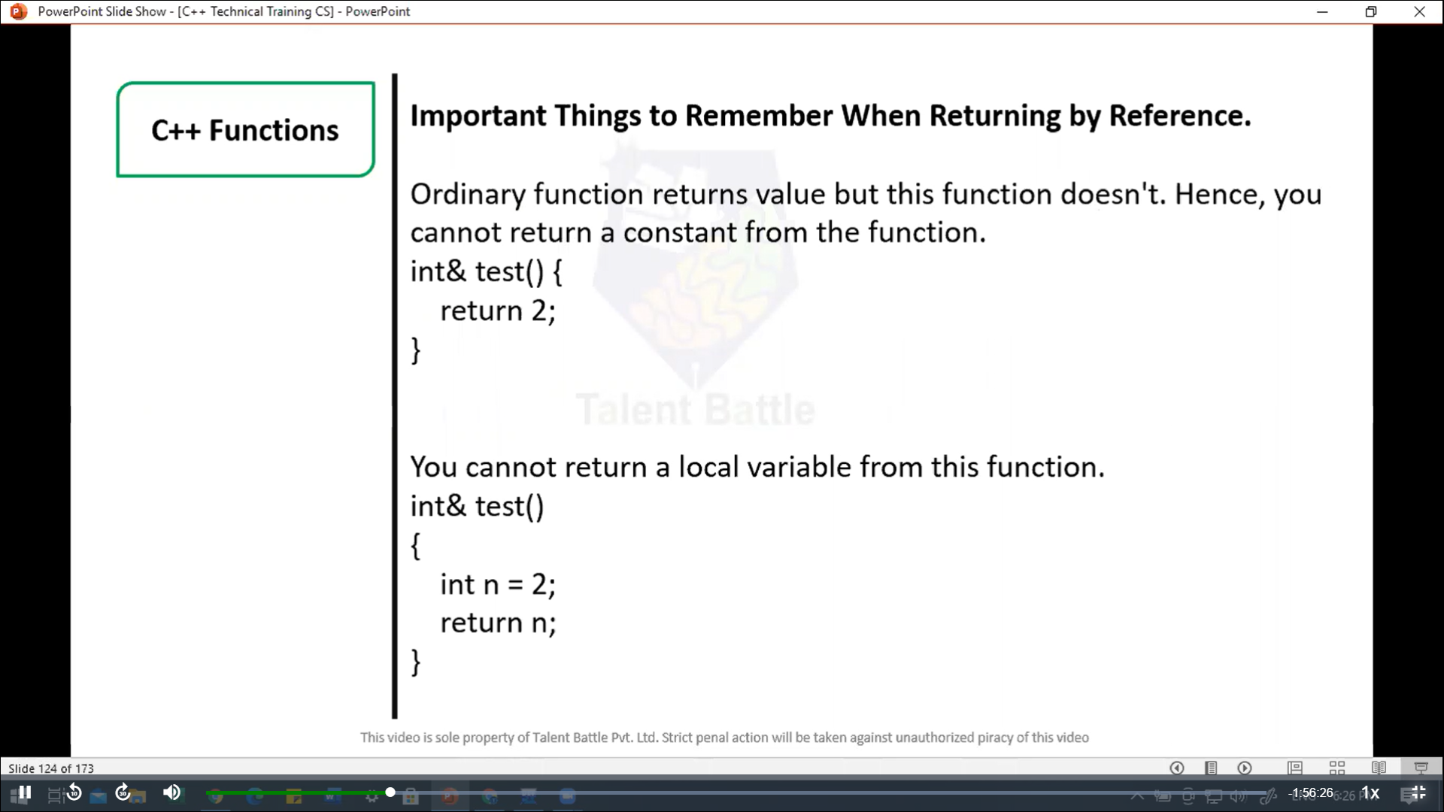

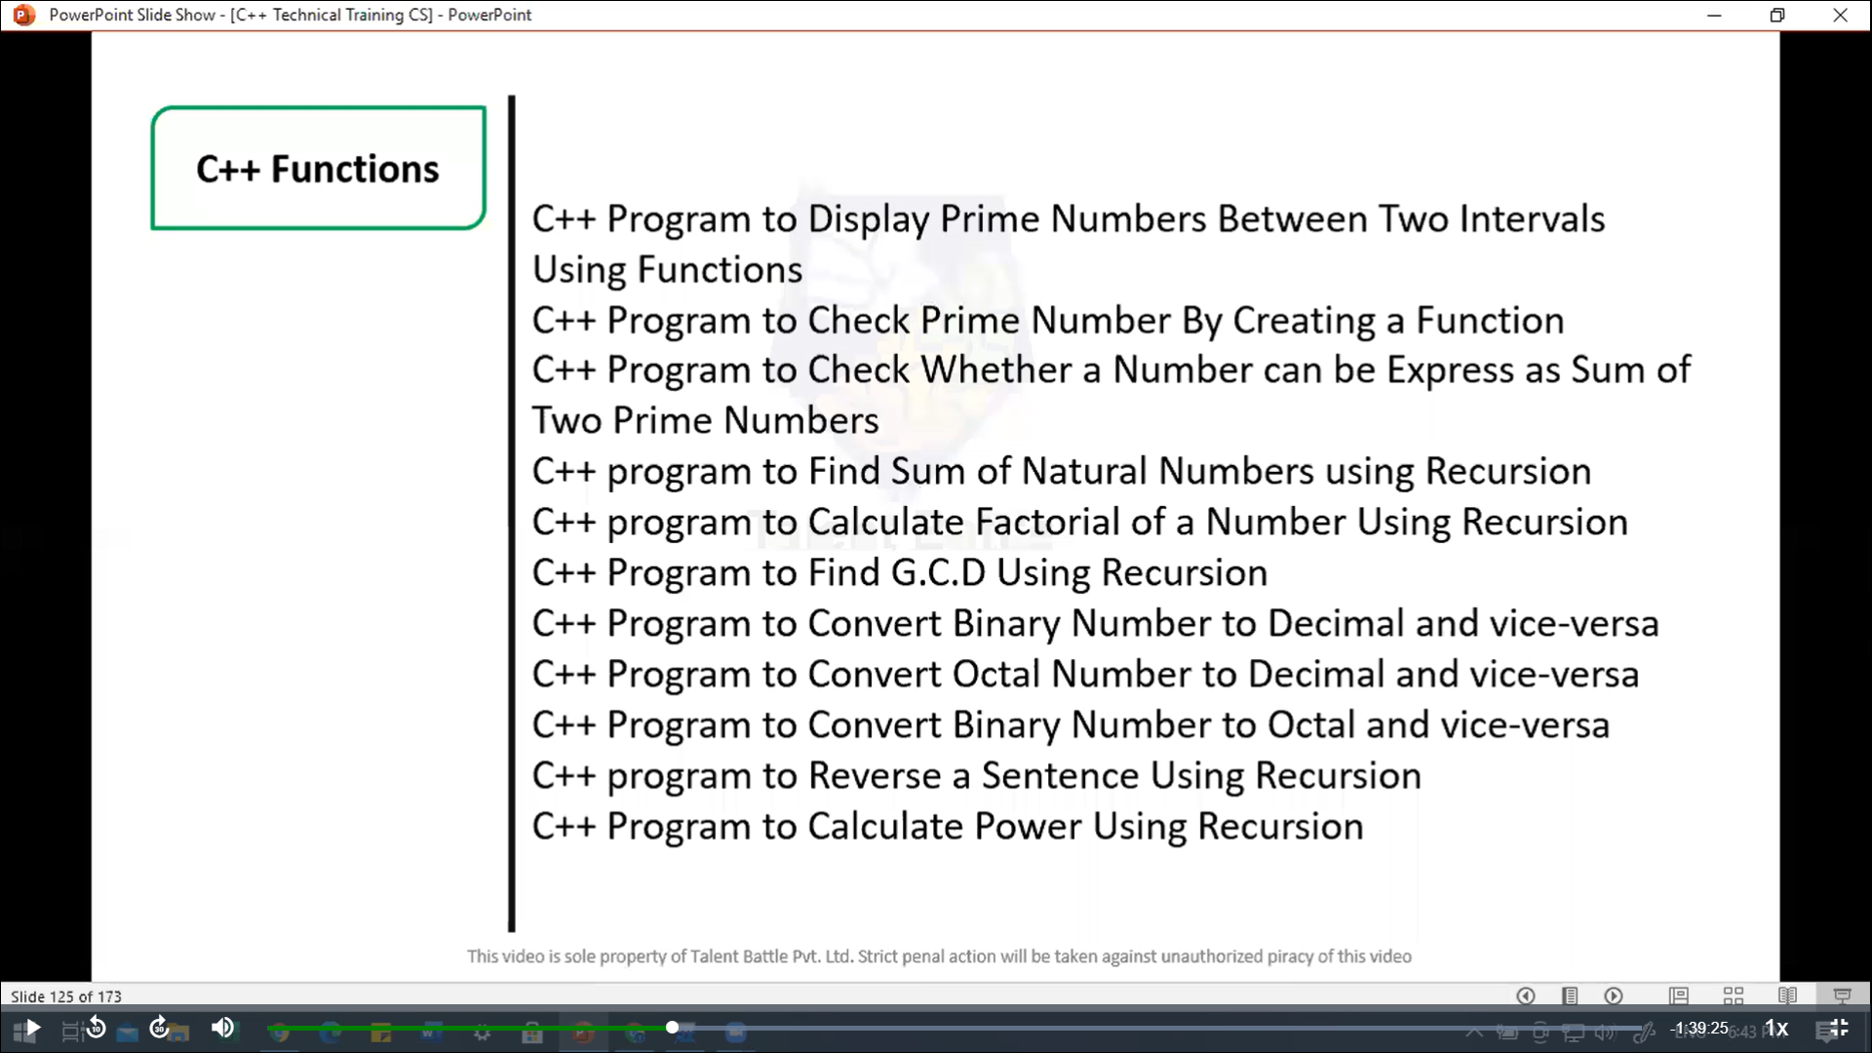

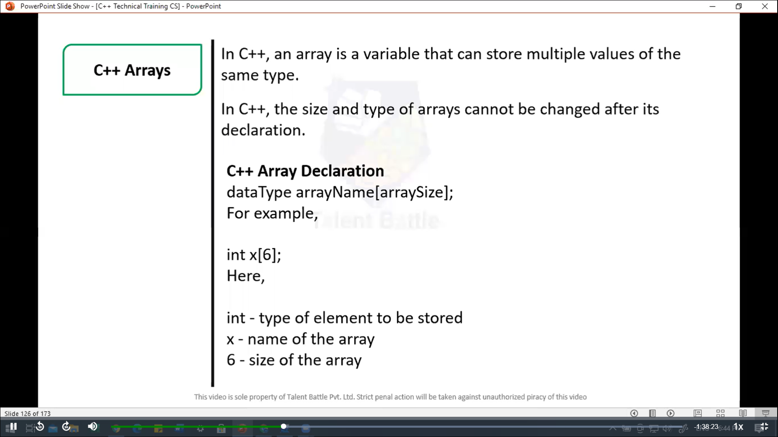

//===============================================

// C++ Program to display prime number between two intervals using functions

#include <iostream>

using namespace ***std***;

// function to check if a number is prime

bool *isPrime*(int ***num***){

  if(***num*** <= 1) // Prime numbers are greater than 1

    return **false**;

  for(int i = 2; i <= ***num*** / 2; ++i){

    if(***num*** % 2 == 0)

      return **false**;

  }

  return **true**;

}

// function to print prime numbers between two intervals

void *printPrimeInRange*(int ***start,*** int ***end***){

  cout *<<* "Prime number between " *<<* ***start*** *<<* " and " *<<* ***end*** *<<* " are: ";

  for(int i = ***start***; i <= ***end***; ++i){

    if(*isPrime*(i)){

      cout *<<* i *<<* " ";

    }

  }

  cout *<<* *endl*;

}

int *main*(){

  int start***,*** end;

  // input from the user

  cout *<<* "Enter the starting number: ";

  cin *>>* start;

  cout *<<* "Enter the ending number: ";

  cin *>>* end;

  // call function to display prime numbers between the range

*printPrimeInRange*(start***,*** end);

  return 0;

}

/*

Enter the starting number: 1

Enter the ending number: 15

Prime number between 1 and 15 are: 2 3 5 7 9 11 13 15

--------------------------------

Process exited after 9.728 seconds with return value 0

*/

//=======================================================

// C++ program to check prime number by creating a function

#include<iostream>

using namespace ***std***;

// function to check if a number is prime

bool *isPrime*(int ***num***){

  if(***num*** <= 1) // prime number are greater than 1

  {

    return **false**;

  }

  for(int i = 2; i <= ***num***/2; ++i){

    if(***num*** % i == 0) // if the number is divisible by any number other than 1 and itself

    {

      return **false**;

    }

  }

  return **true**; // If no divisors found, it is prime

}

int *main*(){

  int number;

  // Input from the user

  cout *<<* "Enter a number: ";

  cin *>>* number;

  // check if the number is prime using the function

  if(*isPrime*(number)){

    cout *<<* number *<<* " is a prime number." *<<* *endl*;

  } else {

    cout *<<* number *<<* " is not a prime number." *<<* *endl*;

  }

  return 0;

}

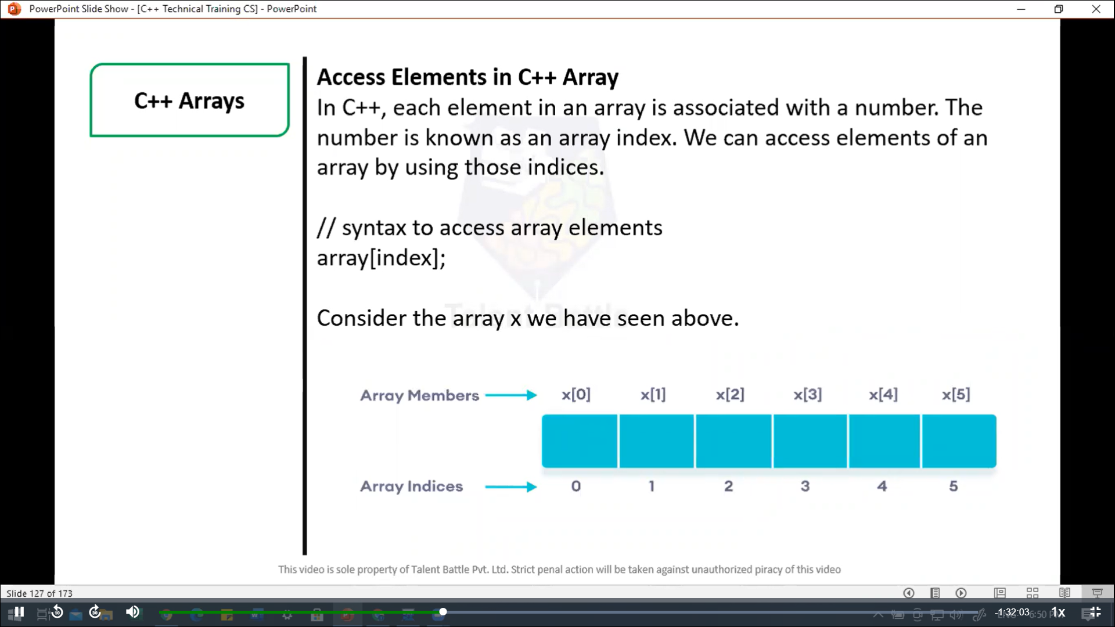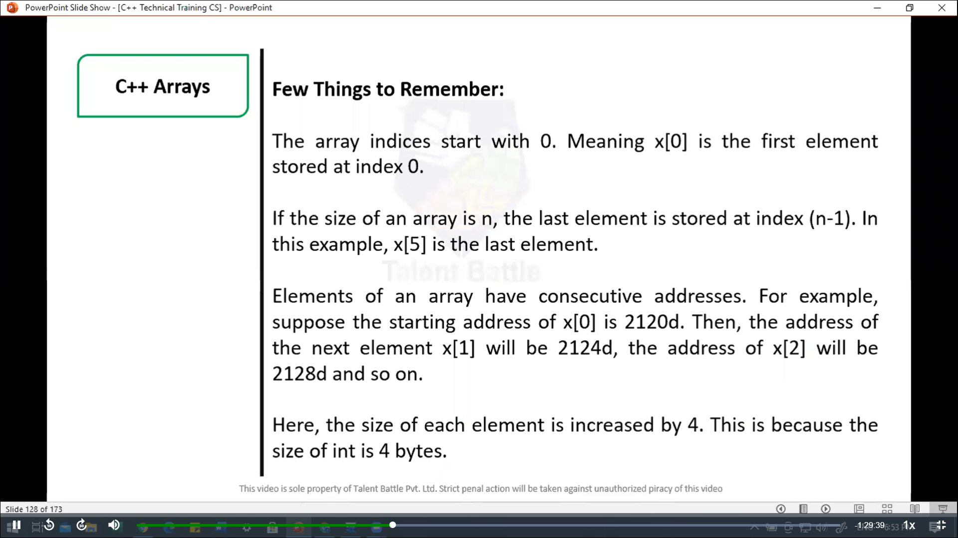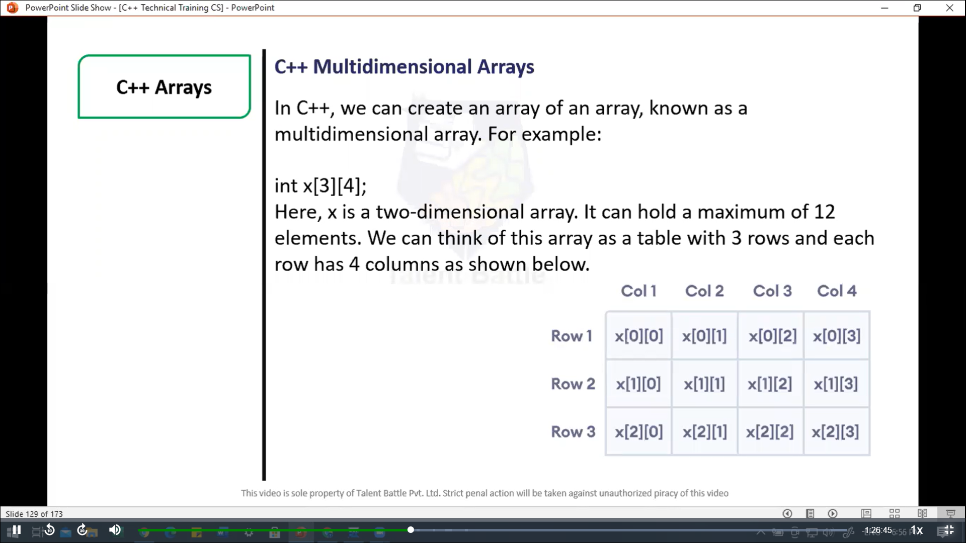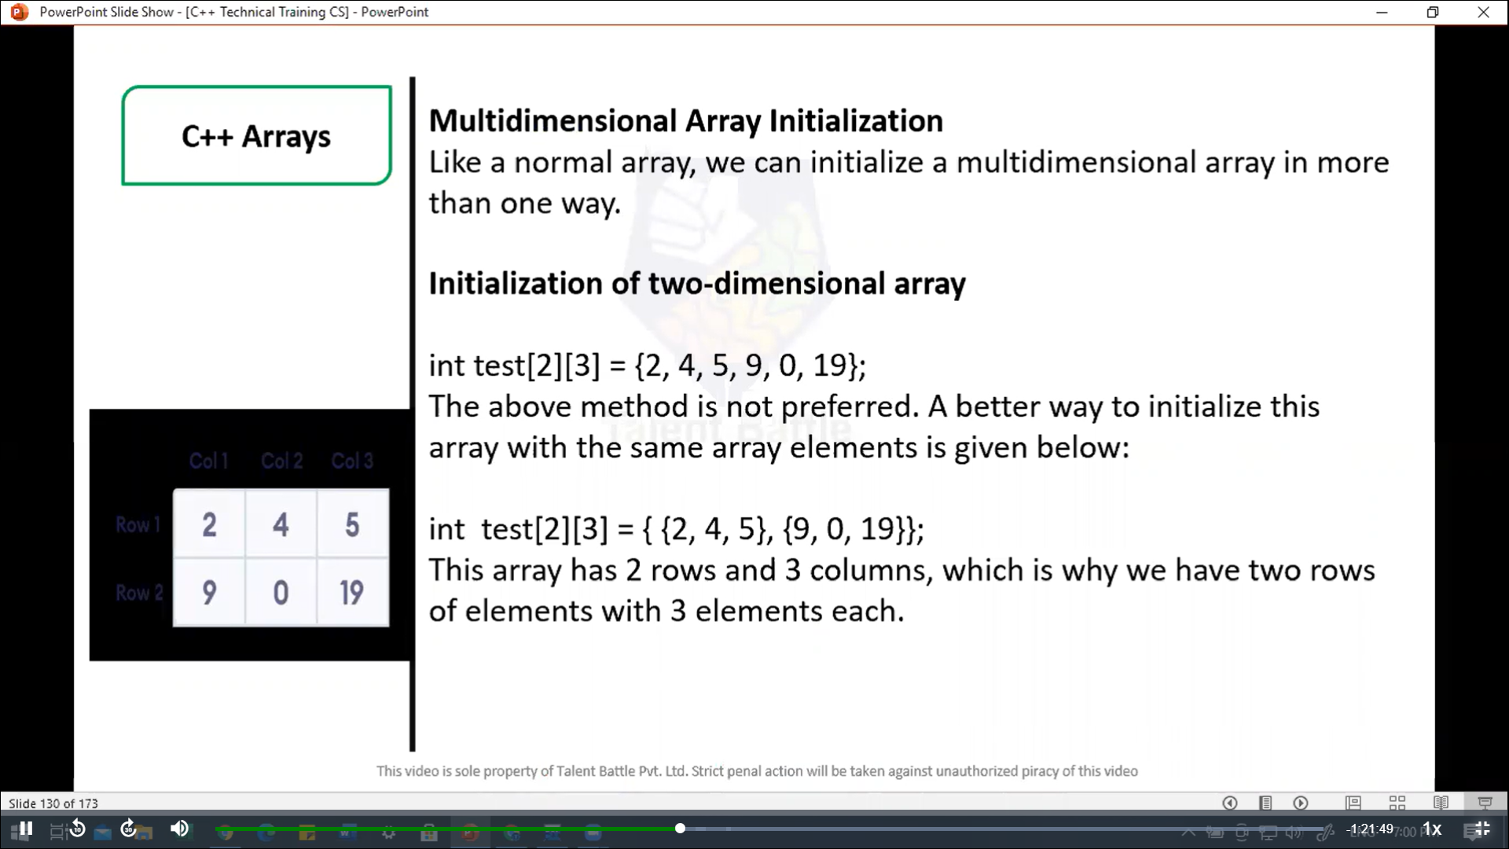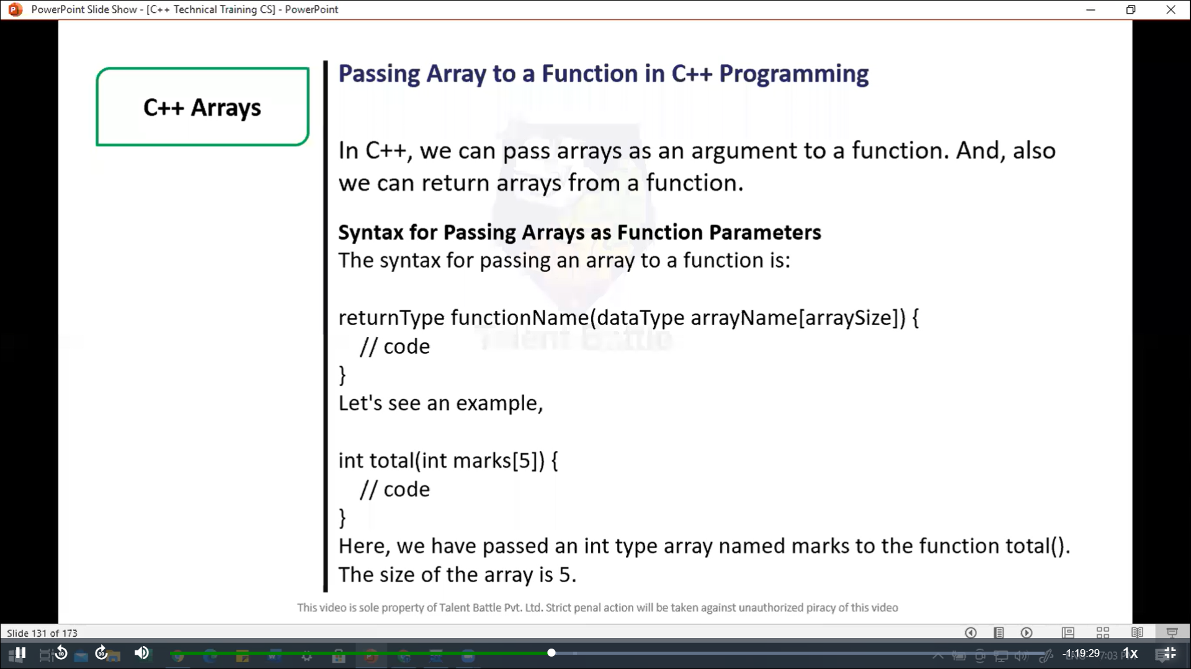

//===============================================

// C++ Program to display marks of 5 students

#include <iostream>

using namespace ***std***;

// declare function to display marks

// take a 1d array as parameter

void *display*(int ***m***[5]){

  cout *<<* "Displaying marks: " *<<* *endl*;

  // display array elements

  for(int i = 0; i < 5; ++i){

    cout *<<* "Student " *<<* i + 1 *<<* ": " *<<* ***m***[i] *<<* *endl*;

  }

}

int *main*(){

  // declare and initialize an array

  int marks[5] = {88***,*** 76***,*** 90***,*** 61***,*** 69};

  // call display function

  // pass array as argument

*display*(marks);

  return 0;

}

/*

Displaying marks:

Student 1: 88

Student 2: 76

Student 3: 90

Student 4: 61

Student 5: 69

--------------------------------

Process exited after 0.06605 seconds with return value 0

*/

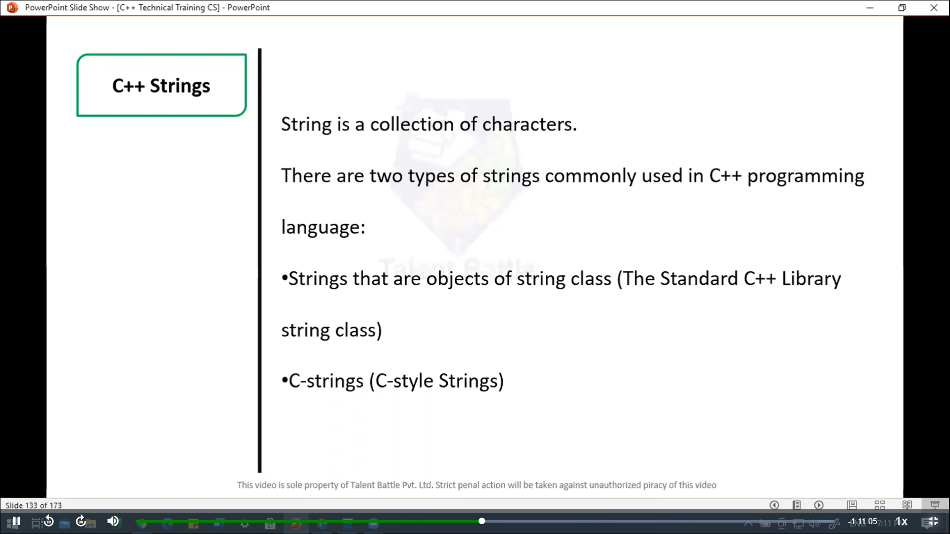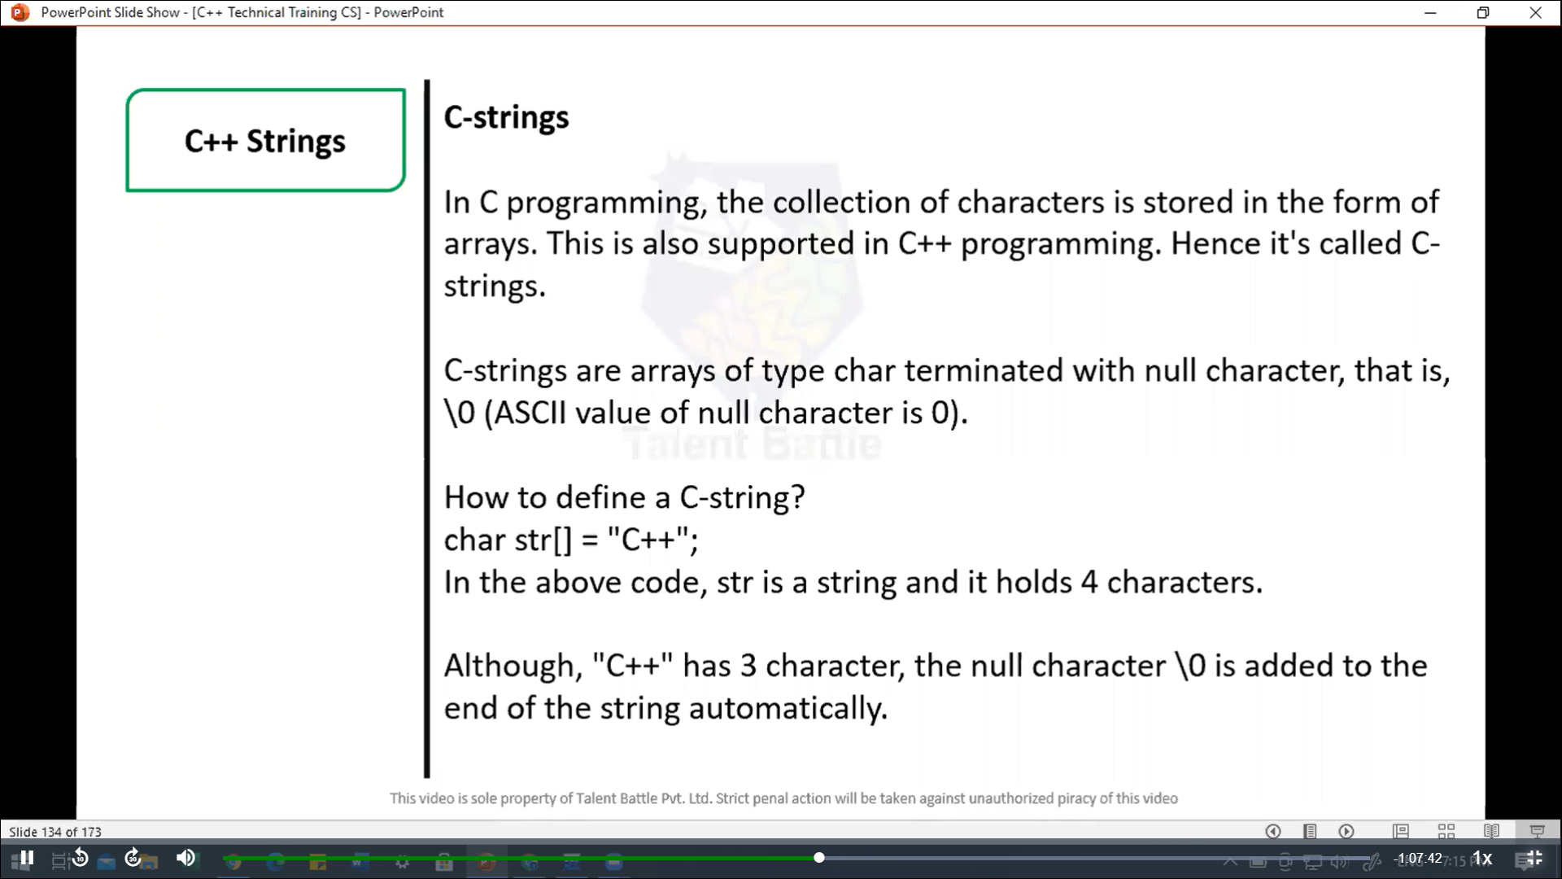

//=====================================================

// C++ Program to display a string entered by user.

/*

The extraction operator >> works as scanf() in c and considers

a space " " has a terminating character.

*/

#include<iostream>

using namespace ***std***;

int *main*(){

  char str[100];

  cout *<<* "Enter a string: ";

  cin *>>* str;

  cout *<<* "You entered: " *<<* str *<<* *endl*;

  cout *<<* "**\n**Enter another string: ";

  cin *>>* str;

  cout*<<* "You entered: " *<<* str *<<* *endl*;

  return 0;

}

/*

Enter a string: best

You entered: best

Enter another string: C++_language

You entered: C++_language

--------------------------------

Process exited after 16.61 seconds with return value 0

*/

//================================================

// C++ program to read and display an entre line entered by user.

#include<iostream>

using namespace ***std***;

int *main*(){

  char str[100];

  cout *<<* "Enter a string: ";

  cin***.****get*(str***,*** 100);

  cout *<<* "You entered: " *<<* str *<<* *endl*;

  return 0;

}

/*

Enter a string: Best language is C++ for window application

You entered: Best language is C++ for window application

--------------------------------

Process exited after 63.44 seconds with return value 0

Press any key to continue . . .

*/

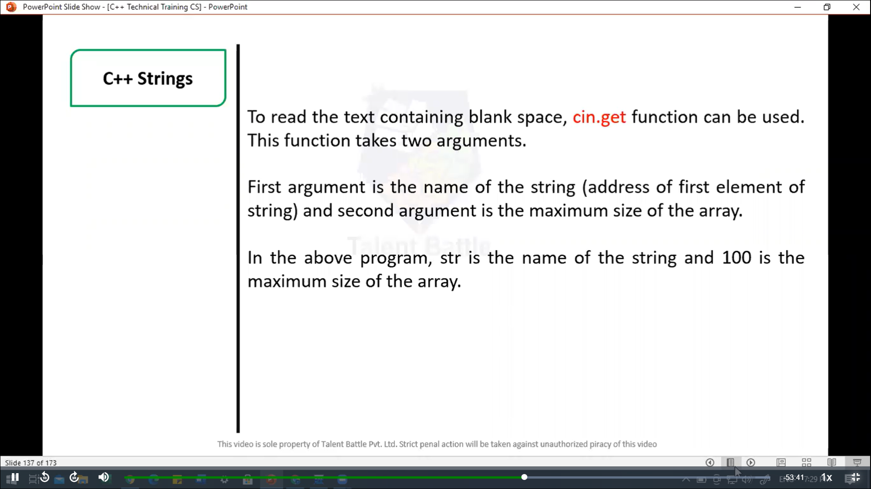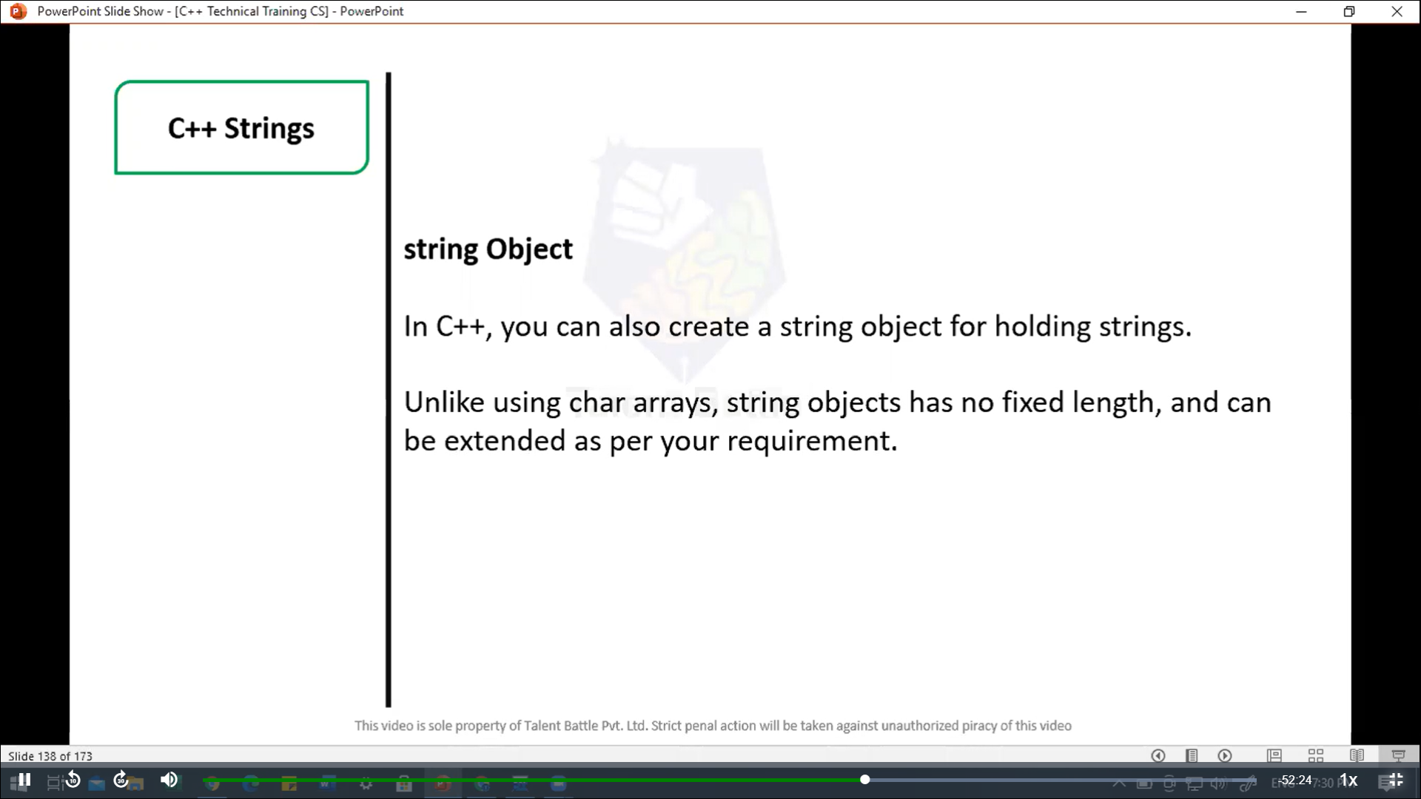

//==================================================

/*

In this program, a string str is declared. Then the

string is asked from the user

Instead of using cin >> or cin.get() function,

you can get the entered line of text using getline().

getline() function takes the input stream as the first

parameter which is cin and str as the location of the line

to be stored.

*/

#include<iostream>

using namespace ***std***;

int *main*(){

  // declaring a string object

  string str;

  cout *<<* "Enter a string: ";

*getline*(cin***,*** str);

  cout *<<* "You entered: " *<<* str *<<* *endl*;

  return 0;

}

/*

Enter a string: This is the best programming language. I want to crack Google as a software engineer.

You entered: This is the best programming language. I want to crack Google as a software engineer.

--------------------------------

Process exited after 41.87 seconds with return value 0

*/

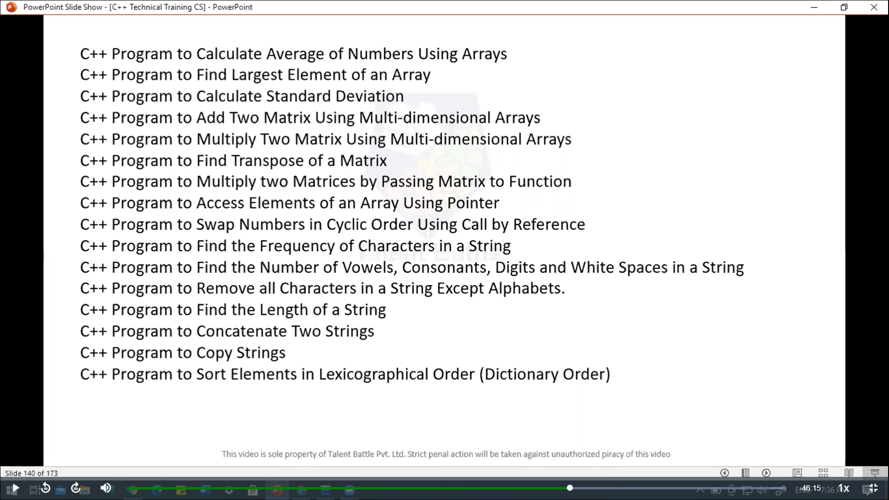

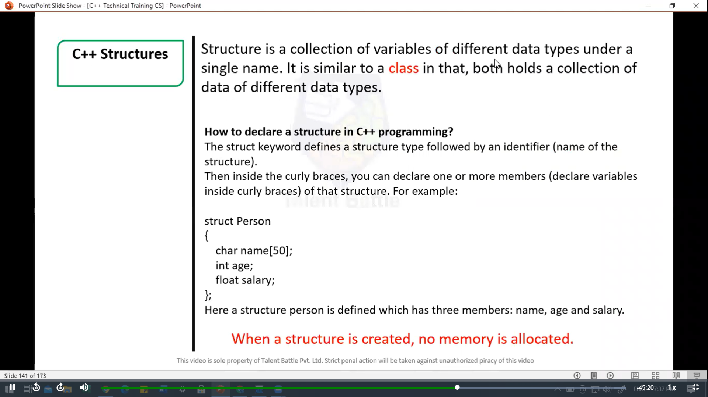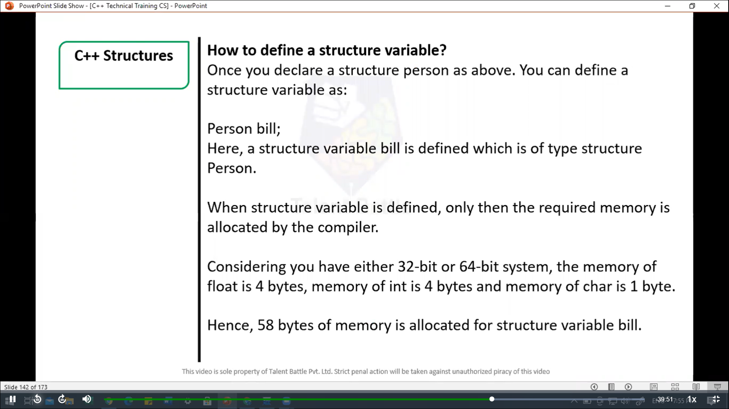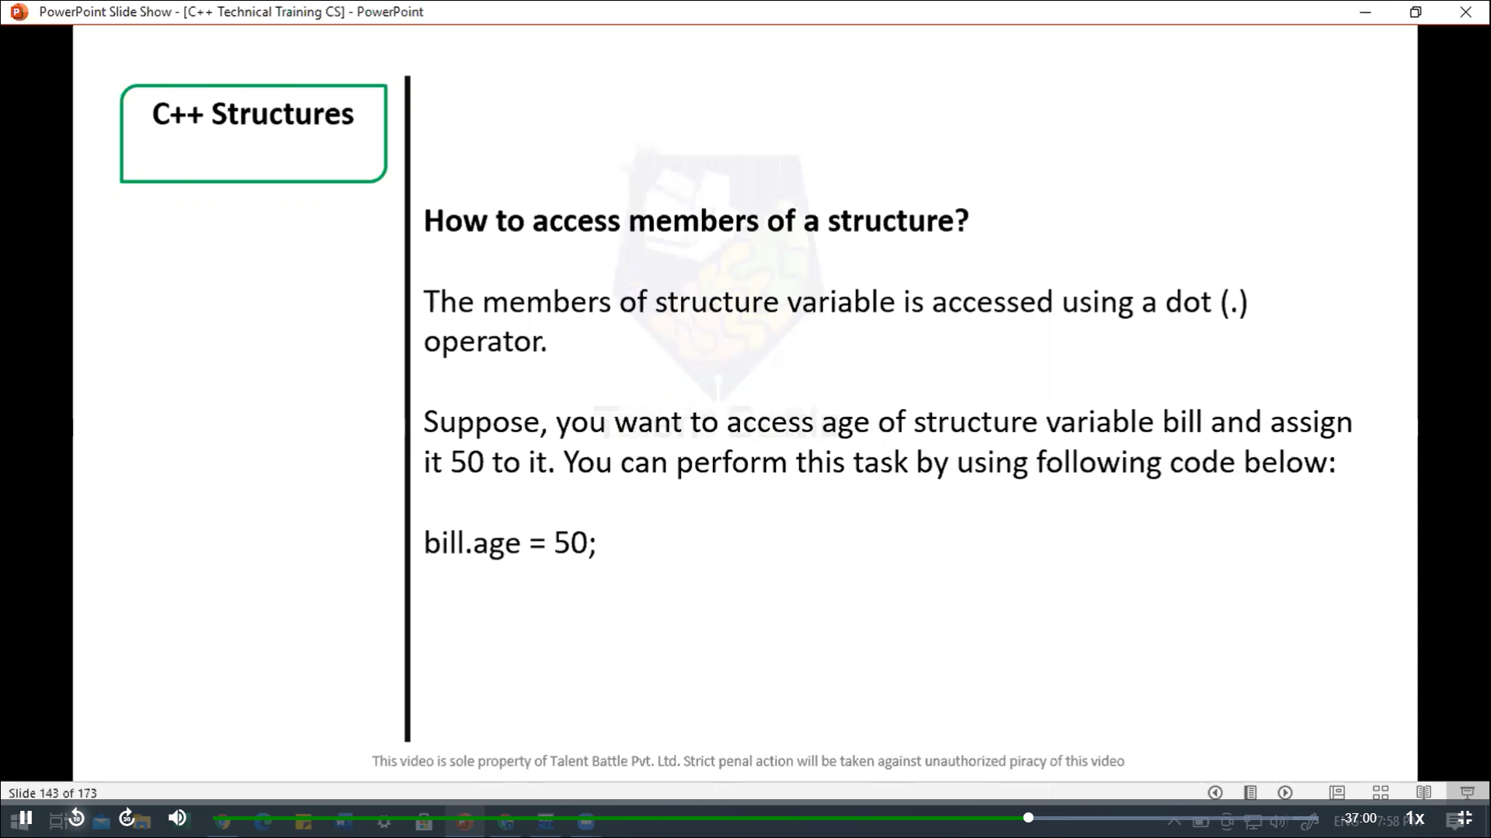

//=======================================================

// C++ structues

#include<iostream>

using namespace ***std***;

struct Person {

  char name[50];

  int age;

  float salary;

};

int *main*(){

  Person p1;

  cout *<<* "Enter Full name: ";

  cin***.****get*(p1***.***name***,*** 50);

  cout *<<* "Enter age: ";

  cin *>>* p1***.***age;

  cout *<<* "Enter salary: ";

  cin *>>* p1***.***salary;

  cout *<<* "**\n**Displaying Information."*<<endl*;

  cout *<<* "Name: " *<<* p1***.***name *<<* *endl*;

  cout *<<* "Age: " *<<* p1***.***age *<<* *endl*;

  cout *<<* "Salary: " *<<* p1***.***salary;

  return 0;

}

/*

Enter Full name: Dheeraj Kumar

Enter age: 22

Enter salary: 900000

Displaying Information.

Name: Dheeraj Kumar

Age: 22

Salary: 900000

--------------------------------

Process exited after 24.99 seconds with return value 0

*/

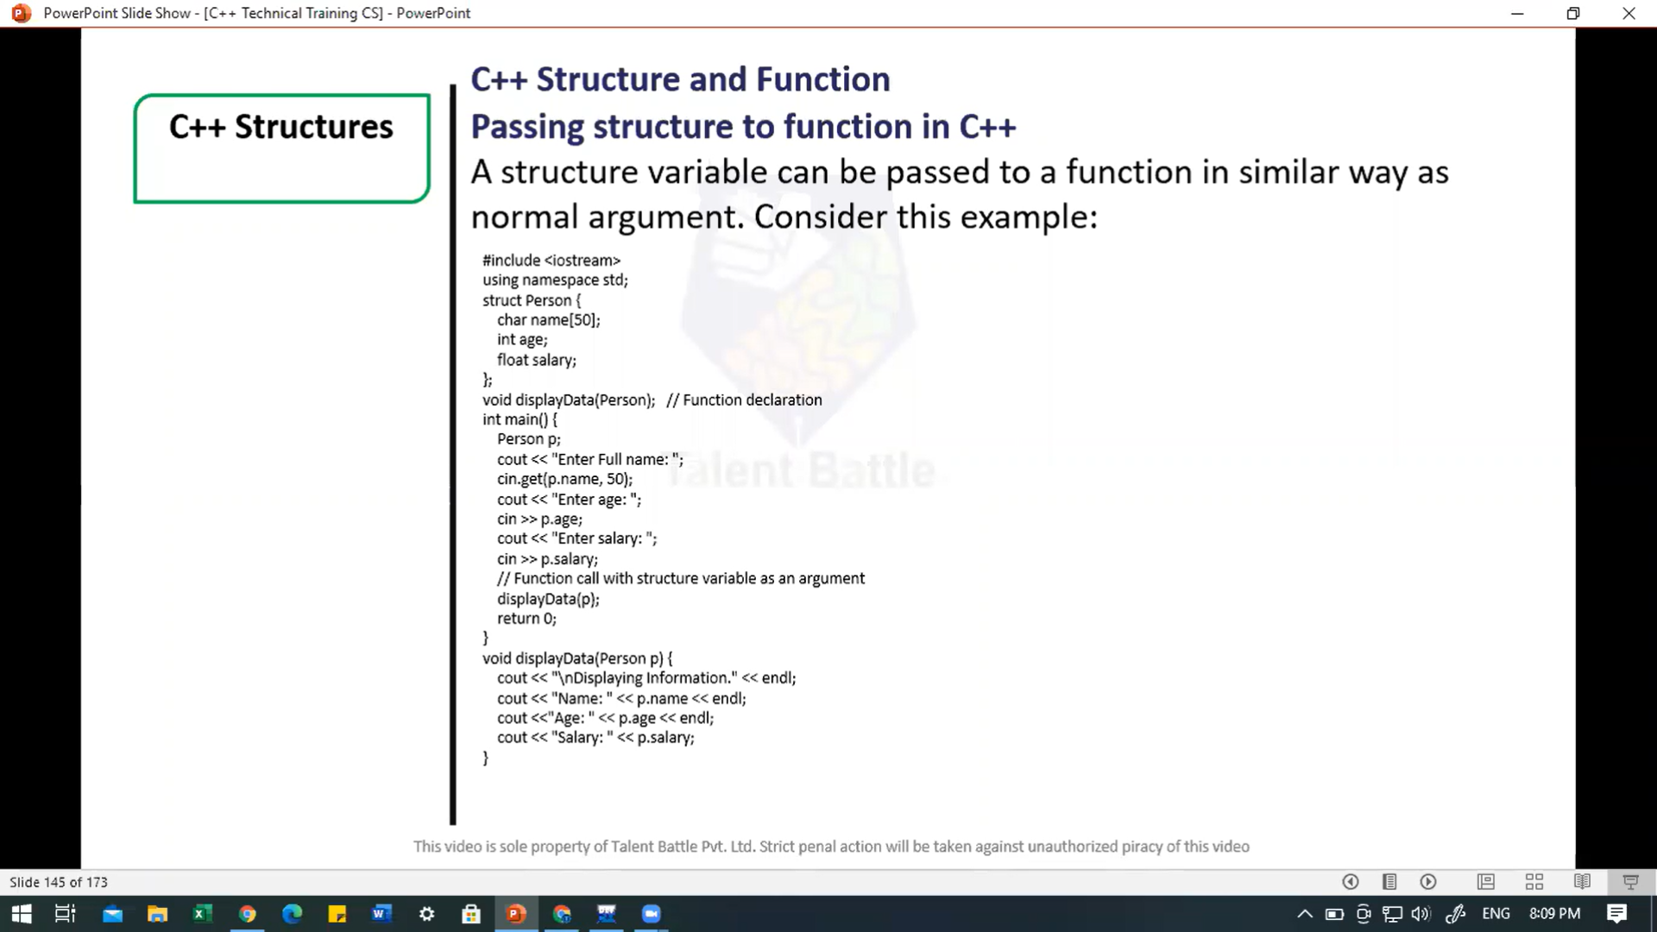

//====================================================

// C++ Structure and function

// passing structure to function in C++

/*

A stucture variable can be passed to a function in similar

way as normal argument. Consider this example:

*/

#include<iostream>

using namespace ***std***;

struct Person {

  char name[50];

  int age;

  float salary;

};

void *displayData*(Person); // Function declaration

int *main*(){

  Person p;

  cout *<<* "Enter full name: ";

  cin***.****get*(p***.***name***,*** 50);

  cout *<<* "Enter age: ";

  cin *>>* p***.***age;

  cout *<<* "Enter salary: ";

  cin *>>* p***.***salary;

  // function call with structure variable as an argument

*displayData*(p);

  return 0;

}

void *displayData*(Person ***p***){

  cout *<<* "**\n**Displaying Information." *<<* *endl*;

  cout *<<* "Name: " *<<* ***p.***name *<<* *endl*;

  cout *<<* "Age: " *<<* ***p.***age *<<* *endl*;

  cout *<<* "Salary: " *<<* ***p.***salary;

}

/*

Enter full name: Dheeraj

Enter age: 22

Enter salary: 900000.99

Displaying Information.

Name: Dheeraj

Age: 22

Salary: 900001

--------------------------------

Process exited after 22.84 seconds with return value 0

*/